Base Radius of a Cylinder
# Source: AI Source: Provided by: [Data Path: Persons Table -> ID Column: 1, Name_En Column: Motasem Essam] -> From: [ChatGPT] on [7/25/2026]
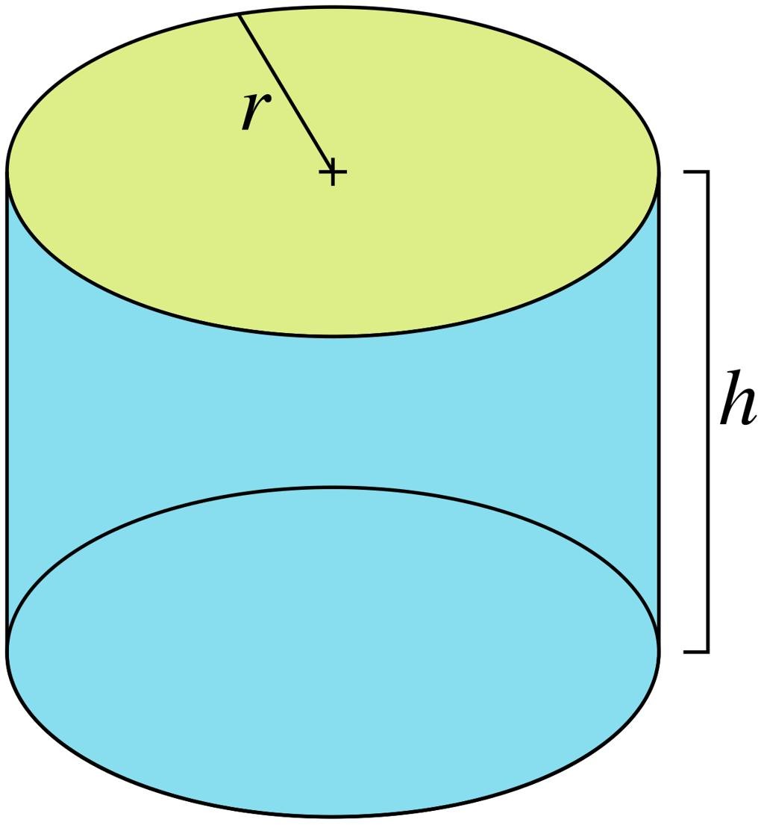
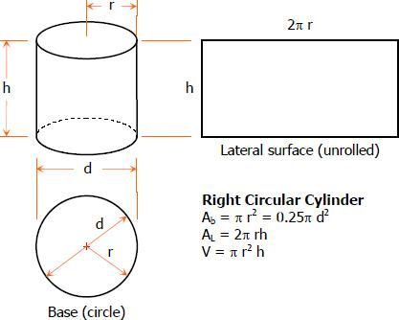
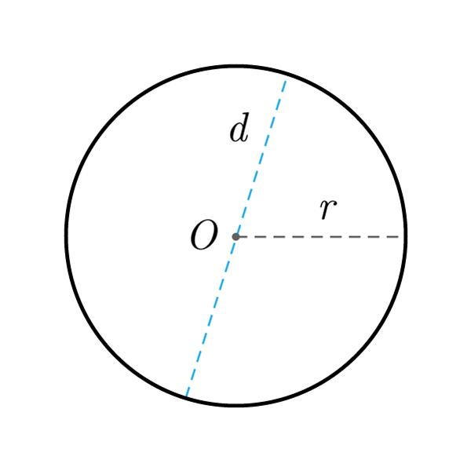

Definition
# Source: AI Source: Provided by: [Data Path: Persons Table -> ID Column: 1, Name_En Column: Motasem Essam] -> From: [ChatGPT] on [7/25/2026]
The base radius of a cylinder is the distance from the center of a circular base to any point on its circumference.
For a circular cylinder with congruent top and bottom bases, both bases have the same radius. The base radius determines the size of the circular faces and is used to calculate the cylinder's circumference, surface areas, and volume.

Simple Definition
# Source: AI Source: Provided by: [Data Path: Persons Table -> ID Column: 1, Name_En Column: Motasem Essam] -> From: [ChatGPT] on [7/25/2026]
The base radius is the distance from the center of a cylinder's circular base to its outer circular edge.
It is usually represented by $r$.
$$\boxed{r=\frac{d}{2}}$$
where $d$ is the diameter of the base.

Geometric Representation and Components
# Source: AI Source: Provided by: [Data Path: Persons Table -> ID Column: 1, Name_En Column: Motasem Essam] -> From: [ChatGPT] on [7/25/2026]
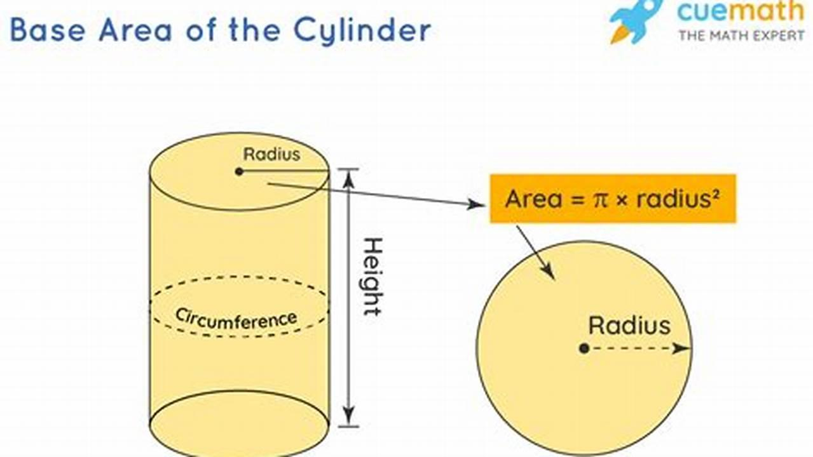
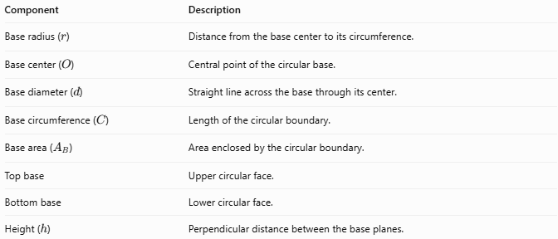
Component | Description
Base radius ($r$) | Distance from the base center to its circumference.
Base center ($O$) | Central point of the circular base.
Base diameter ($d$) | Straight line across the base through its center.
Base circumference ($C$) | Length of the circular boundary.
Base area ($A_{B}$) | Area enclosed by the circular boundary.
Top base | Upper circular face.
Bottom base | Lower circular face.
Height ($h$) | Perpendicular distance between the base planes.
For a cylinder with congruent circular bases:
$$r_{\text{top}}=r_{\text{bottom}}=r$$
The base radius is distinct from the cylinder's height, which measures the perpendicular separation between the bases.

Types and Classification
# Source: AI Source: Provided by: [Data Path: Persons Table -> ID Column: 1, Name_En Column: Motasem Essam] -> From: [ChatGPT] on [7/25/2026]
The base radius can be classified according to the type of cylinder and the boundary being measured.

Top Base Radius
# Source: AI Source: Provided by: [Data Path: Persons Table -> ID Column: 1, Name_En Column: Motasem Essam] -> From: [ChatGPT] on [7/25/2026]
The radius of the upper circular base, measured from its center to its circumference.

Bottom Base Radius
# Source: AI Source: Provided by: [Data Path: Persons Table -> ID Column: 1, Name_En Column: Motasem Essam] -> From: [ChatGPT] on [7/25/2026]
The radius of the lower circular base, measured from its center to its circumference.
For a standard circular cylinder with congruent bases:
$$\boxed{r_{\text{top}}=r_{\text{bottom}}}$$

Base Radius of a Right Circular Cylinder
# Source: AI Source: Provided by: [Data Path: Persons Table -> ID Column: 1, Name_En Column: Motasem Essam] -> From: [ChatGPT] on [7/25/2026]
The base radius is measured in the circular base plane. The axis is perpendicular to that plane.

Base Radius of an Oblique Circular Cylinder
# Source: AI Source: Provided by: [Data Path: Persons Table -> ID Column: 1, Name_En Column: Motasem Essam] -> From: [ChatGPT] on [7/25/2026]
The base radius is measured in exactly the same way as in a right circular cylinder. The difference is that the cylinder's axis is inclined to the base planes.

Inner and Outer Base Radii of a Hollow Cylinder
# Source: AI Source: Provided by: [Data Path: Persons Table -> ID Column: 1, Name_En Column: Motasem Essam] -> From: [ChatGPT] on [7/25/2026]
For a hollow cylinder, such as a pipe, the base has an inner circular boundary and an outer circular boundary.
- $R$ = outer base radius.
- $r$ = inner base radius.
The wall thickness is:
$$\boxed{t=R-r}$$
These are separate measurements; neither should be confused with the radius of a solid cylinder's base.

Mathematical Formulas

Base Radius from the Diameter
# Source: AI Source: Provided by: [Data Path: Persons Table -> ID Column: 1, Name_En Column: Motasem Essam] -> From: [ChatGPT] on [7/25/2026]
$$\boxed{r=\frac{d}{2}}$$

Base Radius from the Circumference
# Source: AI Source: Provided by: [Data Path: Persons Table -> ID Column: 1, Name_En Column: Motasem Essam] -> From: [ChatGPT] on [7/25/2026]
The circumference of a circular base is:
$$C=2πr$$
Therefore:
$$\boxed{r=\frac{C}{2π}}$$

Base Radius from the Base Area
# Source: AI Source: Provided by: [Data Path: Persons Table -> ID Column: 1, Name_En Column: Motasem Essam] -> From: [ChatGPT] on [7/25/2026]
The area of a circular base is:
$$A_{B}=πr^{2}$$
Rearranging:
$$\boxed{r=\sqrt{\frac{A_{B}}{π}}}$$

Base Radius from the Cylinder's Volume
# Source: AI Source: Provided by: [Data Path: Persons Table -> ID Column: 1, Name_En Column: Motasem Essam] -> From: [ChatGPT] on [7/25/2026]
For a circular cylinder:
$$V=πr^{2}h$$
Therefore:
$$\boxed{r=\sqrt{\frac{V}{πh}}}$$

Base Radius from the Lateral Surface Area
# Source: AI Source: Provided by: [Data Path: Persons Table -> ID Column: 1, Name_En Column: Motasem Essam] -> From: [ChatGPT] on [7/25/2026]
For a right circular cylinder:
$$A_{L}=2πrh$$
Rearranging:
$$\boxed{r=\frac{A_{L}}{2πh}}$$

Base Radius from the Total Surface Area
# Source: AI Source: Provided by: [Data Path: Persons Table -> ID Column: 1, Name_En Column: Motasem Essam] -> From: [ChatGPT] on [7/25/2026]
For a closed right circular cylinder:
$$A_{T}=2πr^{2}+2πrh$$
Solving for the positive radius:
$$\boxed{r=\frac{-h+\sqrt{h^{2}+\frac{2A_{T}}{π}}}{2}}$$

Worked Examples
# Source: AI Source: Provided by: [Data Path: Persons Table -> ID Column: 1, Name_En Column: Motasem Essam] -> From: [ChatGPT] on [7/25/2026]
Example 1 — Calculate the Base Radius from the Diameter
A cylinder has a base diameter of $18\text{ cm}$. Find its base radius.
Solution:
$$r=\frac{d}{2}$$
$$r=\frac{18}{2}$$
$$\boxed{r=9\text{ cm}}$$
Example 2 — Calculate the Base Radius from the Circumference
The circumference of a cylinder's base is $16π\text{ m}$. Find the base radius.
Solution:
$$r=\frac{C}{2π}$$
$$r=\frac{16π}{2π}$$
$$\boxed{r=8\text{ m}}$$
Example 3 — Calculate the Base Radius from the Base Area
A circular base has an area of $121π{\text{ cm}}^{2}$. Find its radius.
Solution:
$$r=\sqrt{\frac{A_{B}}{π}}$$
$$r=\sqrt{\frac{121π}{π}}$$
$$r=\sqrt{121}$$
$$\boxed{r=11\text{ cm}}$$
Example 4 — Calculate the Base Radius from the Volume
A cylinder has a volume of $324π{\text{ cm}}^{3}$ and a height of $9\text{ cm}$. Find its base radius.
Solution:
$$r=\sqrt{\frac{V}{πh}}$$
$$r=\sqrt{\frac{324π}{9π}}$$
$$r=\sqrt{36}$$
$$\boxed{r=6\text{ cm}}$$
Example 5 — Calculate the Wall Thickness of a Hollow Cylinder
A hollow cylinder has an outer base radius of $10\text{ mm}$ and an inner base radius of $7\text{ mm}$. Find its wall thickness.
Solution:
$$t=R-r$$
$$t=10-7$$
$$\boxed{t=3\text{ mm}}$$

How the Base Radius Affects a Cylinder
# Source: AI Source: Provided by: [Data Path: Persons Table -> ID Column: 1, Name_En Column: Motasem Essam] -> From: [ChatGPT] on [7/25/2026]
For a right circular cylinder with a fixed height:
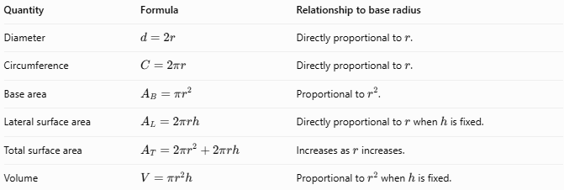
Quantity | Formula | Relationship to base radius
Diameter | $$d=2r$$ | Directly proportional to $r$.
Circumference | $$C=2πr$$ | Directly proportional to $r$.
Base area | $$A_{B}=πr^{2}$$ | Proportional to $r^{2}$.
Lateral surface area | $$A_{L}=2πrh$$ | Directly proportional to $r$ when $h$ is fixed.
Total surface area | $$A_{T}=2πr^{2}+2πrh$$ | Increases as $r$ increases.
Volume | $$V=πr^{2}h$$ | Proportional to $r^{2}$ when $h$ is fixed.
If the base radius doubles while the height remains constant:
- The diameter doubles.
- The circumference doubles.
- The base area becomes four times larger.
- The volume becomes four times larger.
- The lateral surface area doubles.

Base Radius Compared with Related Measurements
# Source: AI Source: Provided by: [Data Path: Persons Table -> ID Column: 1, Name_En Column: Motasem Essam] -> From: [ChatGPT] on [7/25/2026]
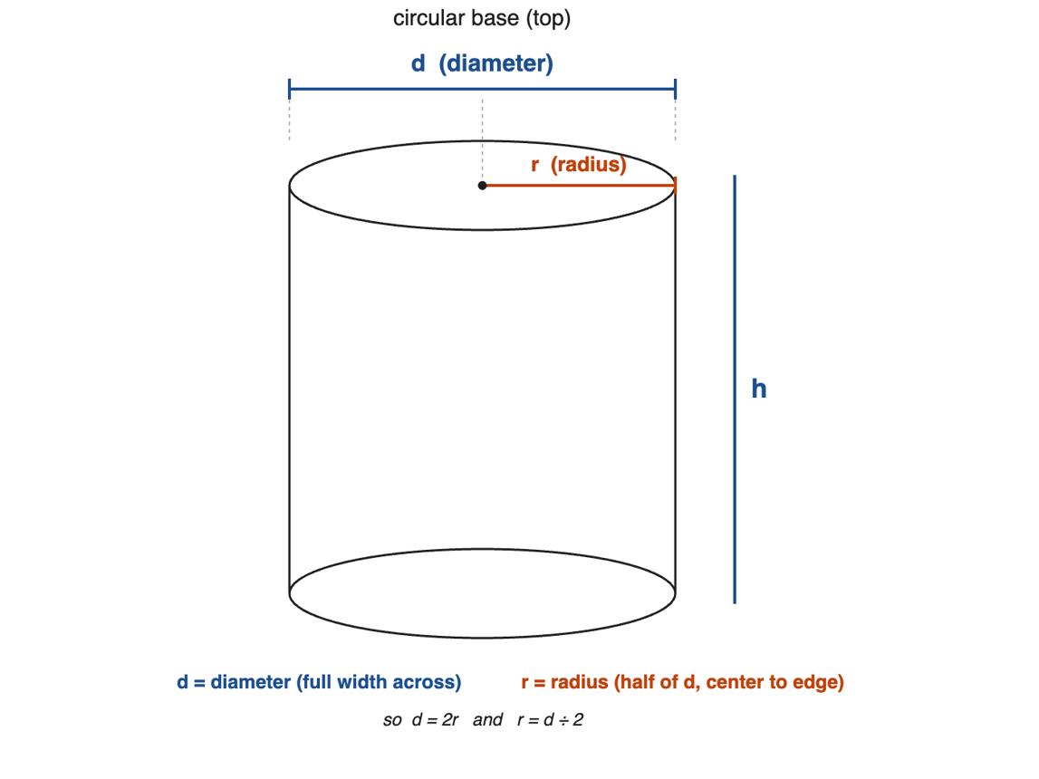
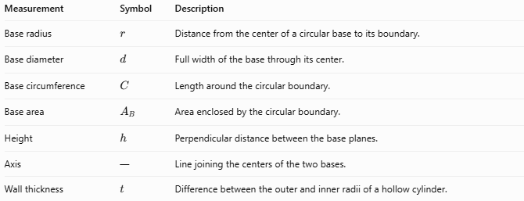
Measurement | Symbol | Description
Base radius | $$r$$ | Distance from the center of a circular base to its boundary.
Base diameter | $$d$$ | Full width of the base through its center.
Base circumference | $$C$$ | Length around the circular boundary.
Base area | $$A_{B}$$ | Area enclosed by the circular boundary.
Height | $$h$$ | Perpendicular distance between the base planes.
Axis | — | Line joining the centers of the two bases.
Wall thickness | $$t$$ | Difference between the outer and inner radii of a hollow cylinder.
Important distinction: The base radius describes the size of the circular base, while the height describes the separation between the two bases.

Applications
# Source: AI Source: Provided by: [Data Path: Persons Table -> ID Column: 1, Name_En Column: Motasem Essam] -> From: [ChatGPT] on [7/25/2026]
The base radius is useful for calculating and designing:
- Cans and containers: determining base area and storage capacity.
- Pipes and tubes: specifying inner and outer opening dimensions.
- Water tanks: calculating volume from base radius and height.
- Construction: designing cylindrical columns and foundations.
- Manufacturing: specifying cylindrical shafts, rollers, and components.
- Packaging: estimating the material needed for circular bases and curved sides.

Key Points
# Source: AI Source: Provided by: [Data Path: Persons Table -> ID Column: 1, Name_En Column: Motasem Essam] -> From: [ChatGPT] on [7/25/2026]
- The base radius is the distance from the center of a circular base to its circumference.
- It is commonly represented by $r$.
- For congruent bases, the top and bottom base radii are equal.
- The diameter is twice the base radius: $d=2r$.
- The base area is $A_{B}=πr^{2}$.
- The cylinder's volume is $V=πr^{2}h$.
- A hollow cylinder has distinct inner and outer base radii.

Conclusion
# Source: AI Source: Provided by: [Data Path: Persons Table -> ID Column: 1, Name_En Column: Motasem Essam] -> From: [ChatGPT] on [7/25/2026]
The base radius of a cylinder is a fundamental geometric measurement that determines the size of its circular bases. It is essential for calculating circumference, base area, surface area, and volume.
The two most important formulas are:
$$\boxed{d=2r}$$
$$\boxed{A_{B}=πr^{2}}$$

